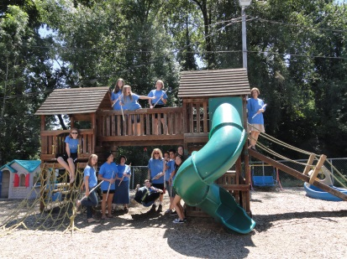
FLUTE ALLIANCE
FLUTE BOOT CAMPS
2015

For flute fun, friends & fundamentals! It’s fantastic!
BOOT CAMPS (Intermediates-Advanced Players):
Large Ensembles, Small Ensembles, Games & Gala Recital!!

CODA CAMP (Advanced-Intermediate through Advanced):
Solo Performance, Solo Repertoire for the Serious Player!!!

Camp Options:
East Side Boot Camp – PDX (Ensembles): June 22-26
Camp Coda – Tigard (Soloists) Seminar: July 7-10
West Side Boot Camp – Tigard (Ensembles): July 13-17

GREAT COACHES:
Sydney Carlson, Portland State University
Denise Westby, Linfield College
Carla Wilson, University of Portland

For registration: flutealliance@comcast.net
503-624-0553, www.flutealliance.com, or find Flute Alliance on Facebook

