
Cindy Christensen—president, Brian Williamson—treasurer, Cindy Morrison--secretary, Robyn Folsom, Karen Groenweghe, Marie Johnson, Polly Doyle —executive board members

P.O Box 594 Sherwood Oregon 97140 vpafoundation.org

Sherwood High School March 6, 2014
16956 SW Meineke Rd
Sherwood, OR 97140

Voices for the Performing Arts Foundation is pleased to announce that it will be offering two scholarships of $1,000 to college bound seniors graduating this year, 2014.

Please help us get the word out by announcing this opportunity to your seniors. The students do not have to commit to majoring in the performing arts next year to apply. Recipients will be notified by May 1st , and awards will be given at the VPA Spring Concert on May 9th and the SHS Honors Banquet on June 2nd .
Attached is an application. Additional applications are available in the Career Center, and on our website www.vpafoundation.org. Applications are to be postmarked by April 18th, 2014. Please direct any questions to kgroenweghe@gmail.com.

Thank you for assistance in promoting this opportunity and for teaching the performing arts to our Sherwood students.

Sincerely
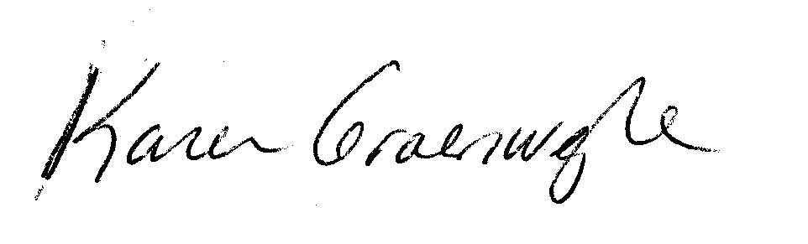
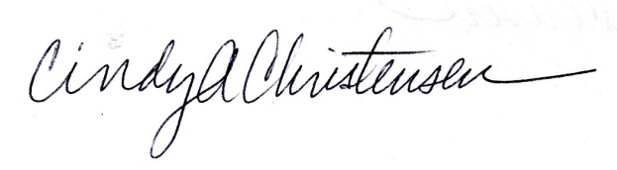

Karen Groenweghe Cindy Christensen
School Grants/Scholarship Director VPA President/Artistic Director

cc: Rebecca Barton, Career Center
Tracie Harbick, Counseling Dept

Voices for the Performing Arts

Scholarship Application Requirements 2014

- Scholarships are awarded to graduating seniors who have demonstrated outstanding passion, involvement and skill in the performing arts throughout their high school years. Students involved in band, choir, dance, musical theater and drama (as a performer or technical crew) are encouraged to apply. Although we hope you will continue to be involved in the performing arts in the future, declaring a related Arts Major in college is not required.

- Submit the signed and dated application form

- Please attach an essay (500 words or less, type-written, single-spaced) describing how your involvement in the performing arts has enriched your life and how you expect your experiences to influence your future.

- Include at the top of your essay the names of colleges where you have been accepted, and where you will be attending.

- Obtain 2 recommendations from teachers or directors and include them (in sealed envelopes).

- All materials must be mailed to the Voices for the Performing Arts Foundation, Attn: Scholarship, PO Box 594, Sherwood OR 97140. Postmarked by Friday, April 18, 2014.

- Scholarship Recipients will be selected and applicants notified by May 1st.

Note: Award certificates will be presented to scholarship winners at the SHS Honors Banquet June 2nd and at the VPA Spring Concert on May 9th evenings. Please mark the dates on your schedule. *Scholarship recipients’ attendance is requested.

- Questions? Contact Karen Groenweghe School Grants/Scholarship Director at kgroenweghe@gmail.com or 503-473-6009

Voices for the Performing Arts
Scholarship Application 2014

Name________________________________________________________________________
E-mail Address_________________________________ Phone Number___________________
Street Address_________________________________________________________________
City___________________________________ OREGON Zip Code___________________
Please list below the music and performing arts classes, community groups, performance opportunities, solo/ensemble contests, church, and other experiences you have had by year.

Colleges you have been accepted to________________________________________________
______________________________________________________________________________

FRESHMAN SOPHOMORE
____________________________________ ____________________________________
____________________________________ ____________________________________
____________________________________ ____________________________________
____________________________________ ____________________________________
____________________________________ ____________________________________
____________________________________ ____________________________________
____________________________________ ____________________________________

JUNIOR SENIOR
____________________________________ ____________________________________
____________________________________ ____________________________________
____________________________________ ____________________________________
____________________________________ ____________________________________
____________________________________ ____________________________________
____________________________________ ____________________________________
____________________________________ ____________________________________

If I am awarded a VPA scholarship, I do hereby grant permission to the Voices for the Performing Arts Foundation to use my name, my list of performing arts accomplishments, the school I plan to attend, as well as my picture to post on their official website. Quotes from my scholarship application may also be used. I understand that no other personal information (such as phone number, address, etc.) will be used.

Date _________ Signature________________________________________________

Printed Name ________________________________________________
Voices for the Performing Arts Scholarship 2014

Teacher, Director, Coach Recommendation

________________________________________is applying for a scholarship from the Voices
for the Performing Arts Foundation. Please fill out the following form, seal in an envelope, and
return to the student. If you prefer, you may answer the questions on another sheet of paper.
This application must be postmarked by Friday, April 18, 2014.

Teacher Name_________________________________________________________
E-mail Address___________________________________ Phone Number__________________
Class or private lesson taught: ______________________________________________________________________________
How long have you known this student? ______________________________________________________________________________

What are the strengths of this student in class, in performance, as a leader, or as a person?
______________________________________________________________________________
______________________________________________________________________________
______________________________________________________________________________
______________________________________________________________________________
______________________________________________________________________________
______________________________________________________________________________
How has this student been exemplary? ______________________________________________________________________________
______________________________________________________________________________
______________________________________________________________________________
______________________________________________________________________________
______________________________________________________________________________
______________________________________________________________________________
______________________________________________________________________________

Signed_________________________________________________Date__________________

