Band Photo Day Fundraiser
featuring
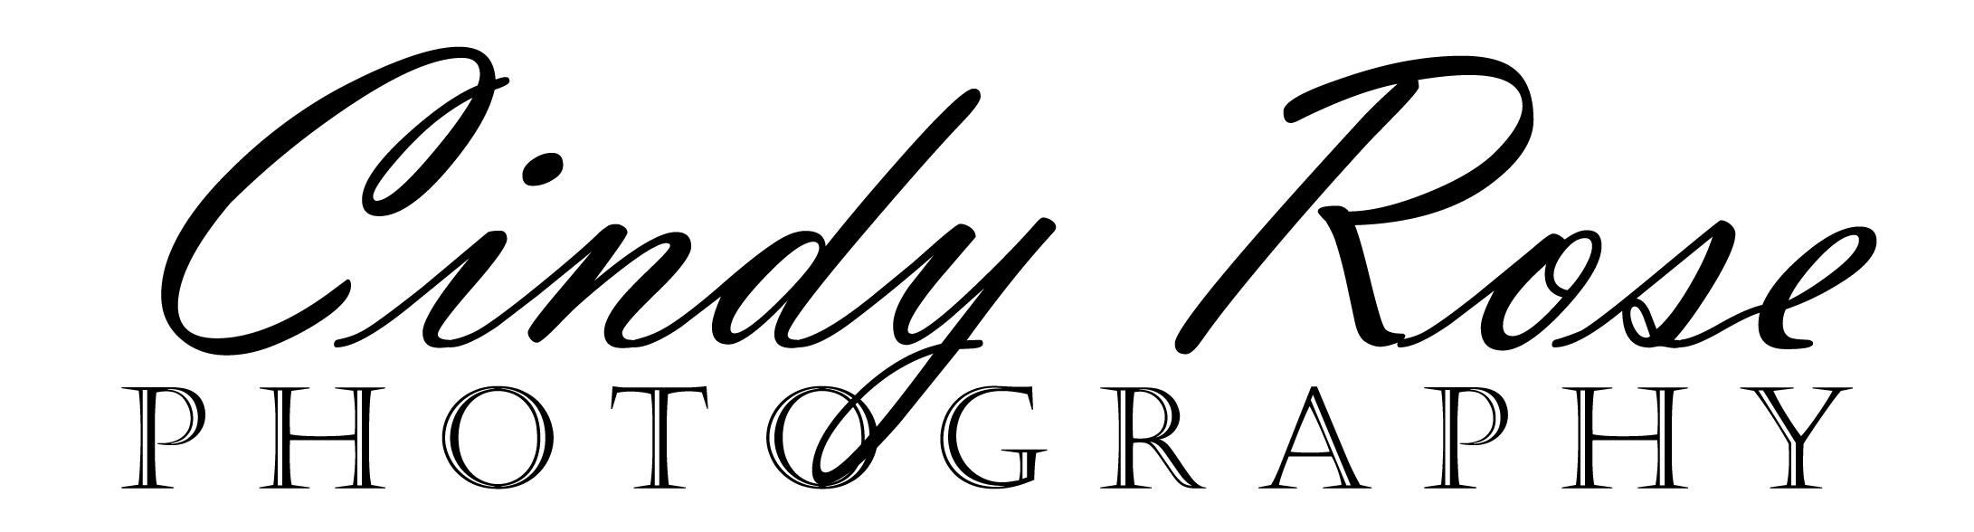

Thursday, October 20th (conference day)
2:00pm- 6:00pm
SHS Band Room

Sign-up sheet will be posted on the Uniform Room door beginning Monday, October 3rd.
All profits go directly to the Sherwood High School Band Booster Club

Professional studio photos with your instrument/flag and/or friends.

Wear your Marching Band/Color Guard uniform, concert attire or WHATEVER you like but be sure to wear your smile!

Options:
Individual Photos $30.00

First Group Photo $15.00 per person

Additional Group Photos * $10.00 per person

*If you would like to have photos taken with more than one group of friends, the charge will be $10.00 per person, per additional sitting.

Limit of (3) group sittings per person.

All Photo Options Include the Following:
Multiple poses (10 plus shots with approximately 3 poses)
Photographer will choose the best shot & professionally touch it up (Photoshop)
1 color 4x6
1 black & white 4x6
High Resolution CD with all poses and reprint release

Questions: Linda Karceski - joeski8@aol.com or 503.625.8094
Michelene Hille - mickih@officespaceplanners.com or 503.625.1141
Please complete the information below and bring it and your payment to Photo Day.

Individual Photo Option:

Student Name __________________________

Instrument or Flag __________________________ Cost: $30.00

First Group Photo Option:

Student Names: __________________________ ____________________________

__________________________ ____________________________

__________________________ ____________________________

(Please list any instruments/flags next to names.) Cost: $15.00

Second Group Photo Option:

Student Names: __________________________ ____________________________

__________________________ ____________________________

__________________________ ____________________________

(Please list any instruments/flags next to names.) Cost: $10.00

Third Group Photo Option:

Student Names: __________________________ ____________________________

__________________________ ____________________________

__________________________ ____________________________

(Please list any instruments/flags next to names.) Cost: $10.00

Total Enclosed _________________
(Checks Payable to SHS Band Booster Club)

